|  |  |  |  |  |  |
| --- | --- | --- | --- | --- | --- |
|  | **S. No.** | **Experiment** | **Date on which the experiment performed** | **Faculty**  **Signature**  **(withdate)** |  |
| **1.** | Write a **SCILAB -CODE** for Arithmetic Operations (on scalars and variables )and Elementary Math Built-in functions. |  |  |
| **2.** | Write a **SCILAB -CODE** for finding addition, subtraction, multiplication and division of matrices , transpose of a matrix and inverse of a non- singular matrix and finding roots of polynomials |  |  |
| **3.** | Write a **SCILAB -CODE** for programming -  Functions - Loops - Conditional statements - Handling sci- files. |  |  |
| **4.** | Write a **SCILAB -CODE** for Plotting 2-D Curves : circle, parabola, ellipse, hyperbola and 3-D surfaces: Planes, Sphere, Cylinder,  Paraboloid, Ellipsoid, Hyperboloid, cone. |  |  |
| **5.** | Write a **SCILAB -CODE** to find expansion of functions in Taylor series. |  |  |
| **6.** | Write a **SCILAB -CODE** for Fourier series expansion of different wave forms and comparison with the original function. |  |  |
| **7.** | Write a **SCILAB -CODE** for identifying the critical points of 2-D and 3-D. surface. |  |  |
| **8.** | Write a **SCILAB -CODE** for computing double integrals in Cartesian coordinates. |  |  |
| **9.** | Write a **SCILAB -CODE** for computing triple integrals in Cartesian coordinates. |  |  |
| **10.** | Write a **SCILAB –CODE** for computing and plotting grad of scalar point function . |  |  |
| **11.** | Write a **SCILAB –CODE** for computing and plotting divergence of vector point functions. |  |  |
| **12.** | Write a **SCILAB –CODE** for computing and plotting curl of Vector point functions. |  |  |

**Experiment-1:**

**To write a SCILAB -CODE for Arithmetic Operations (on scalars and variables )and Elementary Math Built-in functions.**

***Objectives:***

* ***To explain what is Scilab.***
* ***To download and install Scilab software in PC?***
* ***To explain how to work in the main window of Scilab called console***
* ***To explain how Scilab works as a calculator: Arithmetic Operations with scalars(numbers)***
* ***To explain some elementary Math Build-in functions in scilab library***
* ***To explain the variables in Scilab.***
* ***To explain how to work in Scilab editor and write Script Files.***

***Exercises***

**To write a Scilab code to find the solution of following problems:**

* **Evaluate**

**(i) 271/3+320.2 , (ii) sqrt 64 + e4 (iii)**

***(iv)* 4!+ln2+log100, *(v) (2+3i)(4+5i)***

* **By assigning values 2 and 5 to variables a and b respectively, compute (i)c=(a+b)2**

***(ii) d=4a-3b+lna+* c2**

* ***Write the script file for the problem:***

***The radius of a circle is 2cm. Find its area.***

***Solutions***

Exc1 - **271/3+ 320.2**

**Input** :

clc clear

*//exc1*

a=27^(1/3)+32^0.2

b=sqrt(64)+exp(4)

**Output :**

a= 5.

b= 62.59815

c= 1.

d= 26.693147

Exc 2. – **Sqrt 64 + e4**

Input :

clcclear

x= sqrt(64) y= %e^4 z= x+ydisp(z)

Output:

62.598150

iii)

Input :

clc clear

x= sin(%pi/6) y= cosd(60) z= x+ydisp(z)

**Output :**

1.

iv) 4!+1n2+log100

**Input:**

clc clear

a= factorial(4)

b= log(2)

c= log 10(100) z=a+b+cdisp(z)

***Output :***

**26.693147**

**(v) (2+3i)(4+5i)**

**Input:**

clc clear

a= 2+3*%ib= 4+5*%ic= a*b disp(c)

***Output :***

**-7. + 22.i**

**Q2).By assigning values 2 and 5 to variables a and b respectively,compute**

* **c=(a+b)2input**

**Input *:***

clc clear a=2

b=5

c= (a+b)^2

d= (4*a)-(3*b)+log(a)+(c^2) disp(“c=”,c)

disp(“d=”,d)

***Output :***

“c=”

49.

“d=”

2394.6931

***Q3). Write the script for the problem:***

***The radius of the circle is 2cm. Find its area.***

**Input *:***

r=2;

clc clear r=2

A=%pi*r^2

disp(“Area=”,A)

***Output:***

“Area=” 12.566371

***Experiment 2***

**Objectives:**

2.1] Creating 1-d in arrays(vectors).

2.1.1]creating a vector from a known list of numbers.

2.1.2]Creating a vector with constant spacing by specifying the first term, the spacing and the last term.

2.1.3]Creating a vector with linear(equal) spacing by specifying the first and last terms, and the number of terms.

2.2] Creating two-dimensional arrays(Matrix) 2.3] Mathematical operations with arrays 2.4] Finding roots of apolynomial

To write a Scilab code to find the solution of following problems:

**1.(i)**Createarowvectorwith3elements.

***Input***

***x =[6 7 8]***

***disp(x)***

Output

***6. 7. 8.***

(ii) create a column vector with 4 elements

***Input***

***y = [ 6 ;7 ; 8 ; 9 ;]***

***disp(y)***

Output

***6.***

***7.***

***8.***

***9.***

* By taking first term a=1 and the last term b=10 create aone dimensional array:
* by taking the spacing between two consecutive termsd=2

Input clc clear a=1

***b=10***

***d=2 r=[a:d:b] disp(r)***

***Output***

***1.3. 5. 7. 9.***

* by taking the Input: number of terms n=12

***Input clc clear a=1 b=10 n=12***

***r=linspace(a,b,n) disp(r)***

Output

***column 1 to 9***

***1. 1.8181818 2.6363636 3.4545455 4.2727273***

***5.0909091 5.9090909 6.7272727 7.5454545***

***column 10 to 12***

***8.3636364 9.1818182 10.***

* Create two row vectors (one dimensional arrays) a and b suchthat the following operations are defined and hence find:
* 2a-3b

Input

***clc clear***

***A=[4 5 6]***

***B=[1 2 3] R=(2*A)-(3*B)***

disp(R) **Output** 5. 4. 3.

* 2(transpose a)-3(transposeb)

***Input***

***clc clear***

***A=[4 5 6]***

***B=[1 2 3] R=(2*A')-(3*B')***

***disp(R)***

**Output**

***5.***

***4.***

***3.***

* Create two matrices(two dimensional arrays) A and B such thatthe following operations are defined and hence:

(i) 3A-ABt Input

***clc***

***clear***

***A=[7 5;2 4]***

***B=[8 6;1 9] R=3*A-A*B'***

***disp(R)***

**Output**

***-65.-37.***

***-34.-26.***

* Create a matrix A so that the following operationsare defined andfind:
* determinant ofA,
* Inverse of A,
* product of A and inverse of A

***Input***

clc clear

A=[5 7 6;9 4 3;1 5 6]

disp("(i) Determinant=", det(A), "(ii) Inverse=", inv(A)) disp("(iii) Product of A and inverse of A", A*inv(A))

Output

"(i) Determinant="

-66.

"(ii) Inverse="

|  |  |  |
| --- | --- | --- |
| -0.1363636 | 0.1818182 | 0.0454545 |
| 0.7727273 | -0.3636364 | -0.5909091 |
| -0.6212121 | 0.2727273 | 0.6515152 |

"(iii) Product of A and inverse of A"

1. 4.441D-16 8.882D-16

-4.441D-16 1. 4.441D-16

-4.441D-16 2.220D-161.

* Find the roots of followingpolynomials: (i) x2-x-2=0

***Input clc***

***clear***

***A=[1 -1 -2]***

***disp("Roots of A=",roots(A))***

Output

***"Roots ofA=" 2. +0.i***

***-1. +0.i***

***clear***

***A=[1 -1 -2]***

***disp("Roots of A=",roots(A))***

Output

***"Roots ofA=" 2. +0.i***

***-1. +0.i***

***clear***

***A=[1 -1 -2]***

***disp("Roots of A=",roots(A))***

Output

***"Roots ofA=" 2. +0.i***

***-1. +0.i***

**Experiment-3**

**Write a SCILAB -CODE for programming: Functions - Conditional statements-loops in Scilab**

* ***Objectives:***

***Input function, conditional statements, loops and user defined functions***

* Inputfunction
* Conditional statements
* the if-endstructure
* the if-else-endstructure
* the if-elseif-else-endstructure
* loops
* for-endloop
* while-endloop
* user definedfunction
* ***Exercises:***

***( All exercises to be solved on scinotes) Write a Scilab code in a script file:***

***Q1] To find volume and total surface area of a cone using input function.***

***Q2] To find whether an integer entered by user is odd or even, using if- else-end command.***

***Q3] To find whether a real number entered by user is negative, zero or a positive using if- elseif-else-end command.***

***Q4] To find the sum of squares of the first nnatural numbers, using forloop.***

***Q5] To find the sum of squares of the first n natural numbers, using while loop.***

***Q6] To find factorial of a numberusingfor loop. Q7] To find factorial of a number using whileloop.***

***Q8] To find first n terms of Fibonacci sequence using for loop***

***Q9] To find volume and total surface area of a cone using user defined function***

* ***SOLUTION-***
* ***Input***

*//volume of cone-1/3*%pi*R*R*H*

***clc clear***

***r=input("enter r=") h=input("enter h=") v=1/3*%pi*r*r*h disp("volume of cone",v)***

**Output** enter r=3 enter h=4

***"volume of cone" 37.699112***

*//total surface area of cone-%pi*R*(R+L)*

* Input

***clc clear***

***r=input("enter r=") L=input("enter L=") T=%pi*r*(r+L)***

***disp("total surface area of cone",T)***

Output:

***enter r=3 enterL=5***

***"total surface area of cone" 75.39882***

* Input

*//display an integer is even or odd*

***clc clear***

***a=input("enter the number=") if(modulo(a,2)==0)then***

***disp("a is even"); else***

***disp("a is odd"); end***

Output

***enter the number=12 "a is even"***

* ***Input***

***clc clear***

***n=input("enter a number=") if n>0 then***

***disp("The number is positive") elseif n==0***

***disp("you entered zero") else***

***disp("The number is negative") end***

***Output:***

***enter a number=8***

***"The number is positive"***

* **(i)*Input:***

***Clc clear n=0***

***a=input("Enter number of terms= ") s=0***

***for n=(1:a) s=s+(n^2) end***

***disp("Sum= ",s)***

***Output:***

***Enter number of terms= 6***

***"Sum= " 91.***

* ***Input:***

***clc clear***

***n=input("Enter no. of tearms") i=1***

***s=0***

***while i<=n; s=s+(i^2); i=i+1;***

end disp("sum=",s) ***Output:***

***Enter no. of tearms12 "sum="***

***650.***

* Input:

***Clc clear***

***n=input("Enter no. whose factorial is to be found: ") f=1***

***for(i=1:n) f=f*i;***

***end***

***disp("Factorial= ", f)***

***Output:***

***Enter no. whose factorial is to be found: 5***

***"Factorial= " 120.***

* ***Input****:*

***clc clear***

***n=input("Enter no. whose factorial is to be found:") i=1***

***f=1***

***while i<=n; f=f*i; i=i***

***end disp("Factorial=")***

***Output:***

***Enter no. whose factorial is to be found: 8 "Factorial= "***

***40320.***

* (i) Input:

***clc clear***

***n=input("Enter no. of terms= ") s=(1:n)***

***s(1)=1;***

***s(2)=1;***

***for i= 3:n***

***s(i)=s(i-2)+s(i-1); end***

***disp(s)***

***Output:***

***Enter no. of terms= 10***

***column 1 to 9***

***1. 1. 2. 3. 5. 8. 13. 21. 34.***

***column 10***

***55.***

* **Input:**

clc clear

function [**v**, **TSA**]=cone(**r**, **h**) **v**=%pi*(**r**^2)\***h TSA**=%pi*(**r**^2) disp("Volume= ", **v**)

disp("Total Surface Area= ", **TSA**) endfunction

cone(6,12)

***Output***

***"Volume= " 1357.1680***

***"Total Surface Area= " 113.09734***

***Experiment-4***

***Objective***

***4.1.1] 2d Plot of an Explicitly defined function:***

* Basiccode
* Customization of plot: Point Style ,colour, andtitles
* Plotting two functions with same domain. The use oflegends
* Algorithm

***4.1.2] 2d Plots of a function given in parametric form:***

* Algorithm

***4.1.3] 2d plot of implicitly defined function***

* Algorithm

***Exercise***

* Write Scilab code in a scriptfile:
* **To plot Parabola x2=4ay. Take focal lengtha=1.**
* **To plot Circle x2+y2=a2 . Takea=1.**
* **To plot Ellipse x2/ a2 + y2/ b2 =1. Take a=4,b=3.**
* **Plot graph of y1=e x and y2=ln(x) in interval [0.5, 2].**
* **Plot rectangular parabola xy=1 in interval[0.5,2].**

**Solutions**:

* **Input :**

x=linspace(-2,2,20) y=x^2/4

plot (x,y)

xtitle("PARABOLA","X-axis","Y-axis")

**Output :**

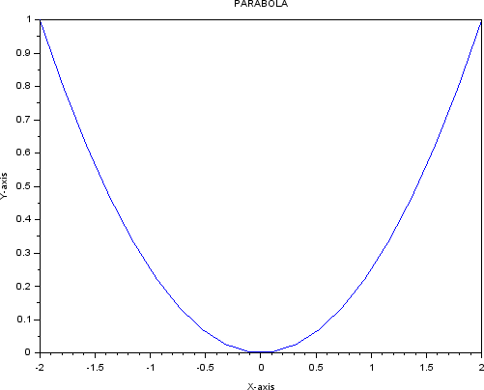

* **Input:**

clear clc

th=linspace(0,2*%pi) r=1

x=r.*cos(th) y=r.*sin(th) plot(x,y)

xtitle("CIRCLE","X-axis", "Y-axis")

**Output:**

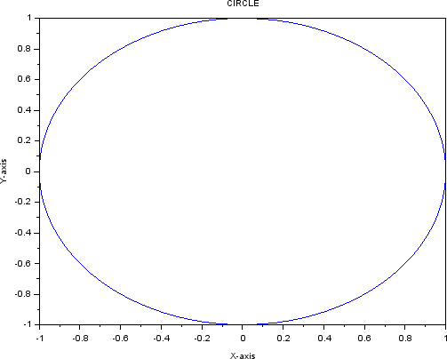

* **Input:**

clear clc

t=linspace(0,2*%pi) x=4.*cos(t) y=3.*sin(t)

plot(x,y)

xtitle("ELLIPSE","X-axis","Y-axis")

**Output:**

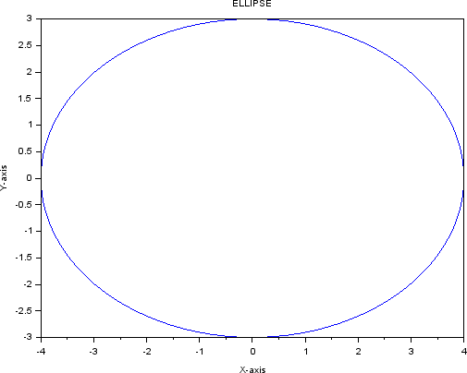

* **Input:**

clear clc

function [**f**]=hyperbola(**x**, **y**) [**f**]=**x**^2/9-**y**^2/16 endfunction

x=linspace(-%pi/2,%pi/2) y=linspace(-%pi/2,%pi/2) contour(x,y,hyperbola,1) xtitle("HYPERBOLA","X-axis","Y-axis")

**Output:**

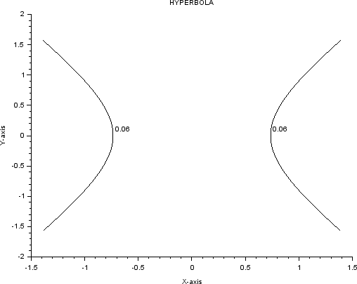

* **Input**:

clear clc

x=linspace(0.5,2) y1=%e^2 plot(x,y1,"g") y2=log(x) plot(x,y2,"c")

xtitle("GRAPH","X-axis","Y-axis")

**Output:**

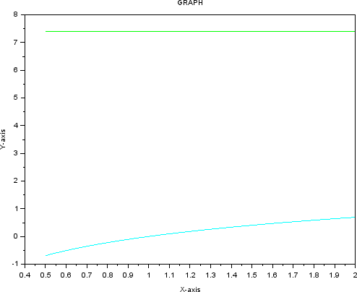

* **Input:**

clear clc

x=linspace(0.5,2) y=1./x

plot(x,y)

xtitle("RECCTANGULAR PARABOLA","X-axis","Y-axis")

**Output:**

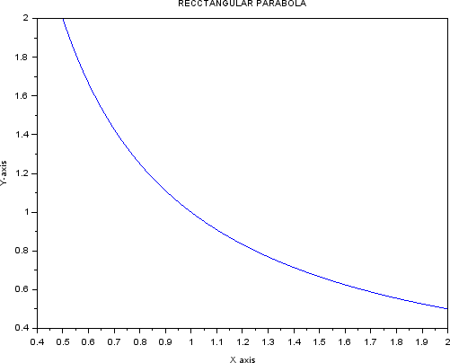

* Write Scilab code in a scriptfile:
* **To plot a Plane ax+ by +cz=d. Take a=b=-1, c=1, d=4.z=4+x+y.**
* **To plot Sphere x2+y2 +z2 =a2 , Takea=1.**
* **To plot right circular Cylinderx2+y2=a2.**
* **To plot parabloid*z/c=* x2/a2 +y2/b2 . Takea=b=c=1.**
* **To plot Ellipsoid x2/a2 +y2/b2 + z2/c2 =1 . Takea=4,b=3,c=2.**
* **To plot Hyperboloid x2/a2 +y2/b2 - z2/c2 =1 . Takea=4,b=3,c=2.**
* **To plot (elliptical)Cone (z/c)2= (x2/a2+ y2/b2) . Take a=b=c=1.**

**Solutions:**

* ***Input :***

***function z=f(x, y) z=4+x+y; endfunctionx=linspace(-2,2,100); y=linspace(-2,2,200); z=feval(x,y,f)';***

***clf surf(x,y,z)***

**Output:**

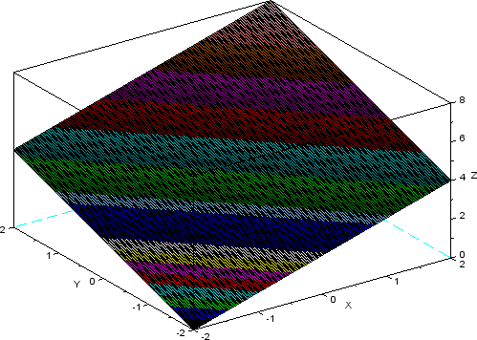

* **Input:**

***a =linspace(0,360,100); th=linspace(-90,90,50); R =1;***

***[A,Th]=meshgrid(a,th); Z = R*sind(Th);***

***X = R*cosd(Th).*cosd(A); Y = R*cosd(Th).*sind(A); Ncolors=100;***

***clf surf(X,Y,Z)***

**Output:**

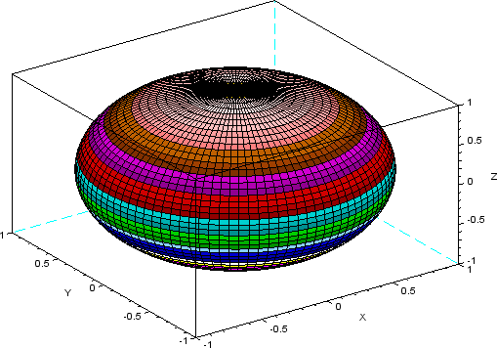

* **Input :**t=linspace(0,2*%pi,100); x1=linspace(0,4,100); [T,X1]=meshgrid(t,x1); x=2*cos(T);y=2*sin(T);z=(X1); surf(x,y,z)

**Output:**

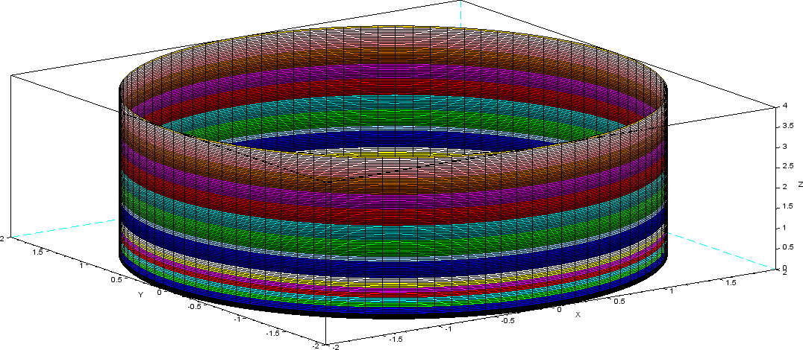

* **Input:**

***function z=f(x, y) z=x^2+y^2; endfunctionx=linspace(-1,1,100); y=linspace(-1,1,200); z=feval(x,y,f)';***

***clf surf(x,y,z)***

**Output:**

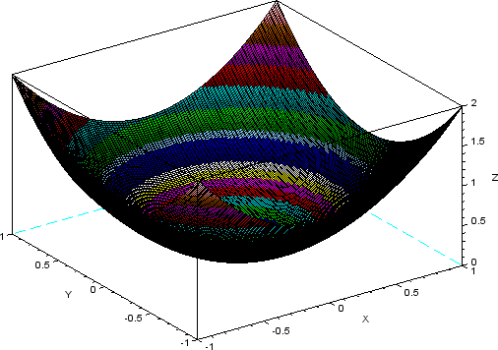

* **Input:**

***a =linspace(0,360,100); th=linspace(-90,90,50); R =1;***

***[A,Th]=meshgrid(a,th); Z =2*R*sind(Th);***

***X =3*R*cosd(Th).*cosd(A); Y =2*R*cosd(Th).*sind(A); Ncolors=100;***

***clf***

***surf(X,Y,Z)***

**Output:**

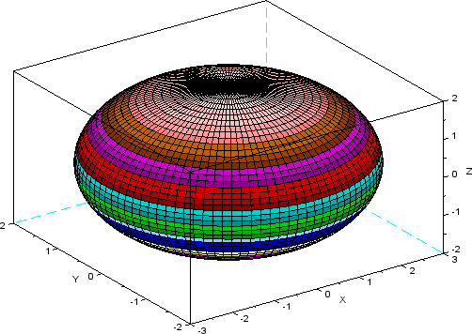

* **Input:**

***a =linspace(0,360,100); th=linspace(-90,90,50); R =1;***

***[A,Th]=meshgrid(a,th); Z =2*R*sinh(Th);***

***X =3*R*cosh(Th).*cosd(A); Y =2*R*cosh(Th).*sind(A); Ncolors=100;***

***clf***

***surf(X,Y,Z)***

**Output:**

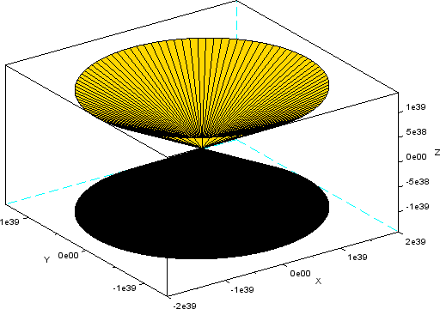

* **Input:**

***function z=f(x, y) z=sqrt(x^2/4+y^2/9); endfunction***

***x=linspace(-300,300,50); y=linspace(-300,300,50); z=feval(x,y,f)';***

***clf surf(x,y,z)***

**Output:**

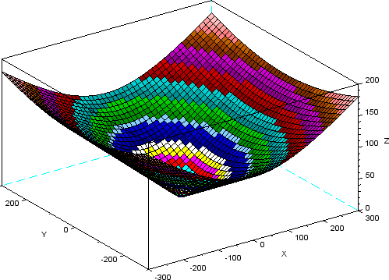

***EXPERIMENT 5***

***Objectives:***

*To write a* SCILAB -CODE

5.1. To find the error in estimated value (yest) of a function f(x) at a point x using its Taylor series.

5.2. To compare a function f(x) and its Taylor series expansion using 2d plots.

***Excercises***

**Write a Scilab code in a script file:**

5.1.1] To find the***error***in estimating the value of functionf(x)=ex at x=1 using its Taylor series expansion about origin.

5.1.2] To find the***error***in estimating the value of functionf(x)=sin(x) at x=pi/2 using its Taylor series expansion about origin.

5.2.1] To compare the function f(x)=exand its Taylor seriesexpansion about origin by using 2d plots

5.2.2] To compare the function f(x)=sin(x)and its Taylorseries expansion about origin by using 2d plots

***Solution***

***5.1.1] Input:***

clc;

clear;

a=0

x=1

y=%e^x

yest=0

n=1

for i=0:1:n

yest=yest+x^i/factorial(i)

end

disp(y)

disp(yest)

error=abs(y-yest)

disp(error)

***Output:***

2.7182818

2.

0.7182818

***5.1.2] Input:***

clc;

clear;

a=0

x=%pi/2

y=sin(x)

yest=0

n=10

for i=0:1:n

yest=yest+((-1)^i)*(x^(2*n+i)/factorial(2*n+1))

end

disp(y)

disp(yest)

error=abs(y-yest)

disp(error)

***Output:***

***1.***

***9.211D-15***

***1.0000000***

***5.2.1] Input:***

clc;

clear;

x=linspace(-10,10,100)

y=%e^x

yest=0

n=10

for i=0:1:n

yest=yest+x^i/factorial(i)

end

plot(x,y,"r")

plot(x,yest)

error=abs(y-yest)

disp(error)

***Output:***

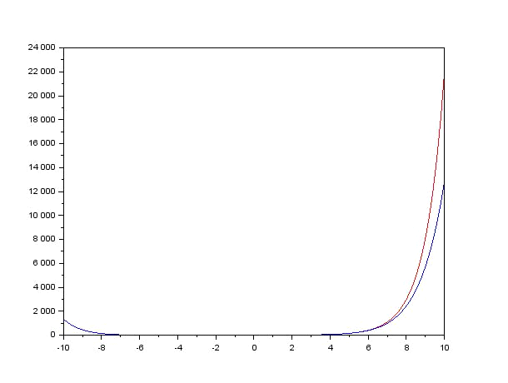

***5.2.2] Input:***

clc;

clear;

x=linspace(-%pi,%pi,100)

y=sin(x)

yest=0

n=1

for i=0:1:n

yest=yest+((-1)^i)*(x^(2*i+1)/factorial(2*i+1))

end

plot(x,y,"r")

plot(x,yest)

xtitle("Graph of sin(x).and.itstaylor series")

error=abs(y-yest)

disp(error)

***Output :***

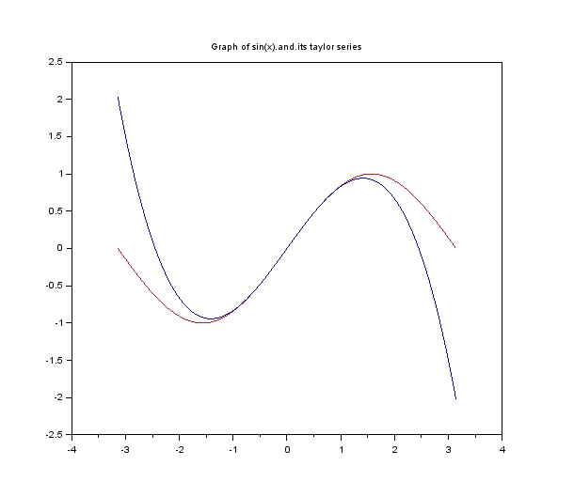

***Experiment-6***

**Write a SCILAB -CODE for Fourier Half Range series expansion of different wave forms and comparison with the original function.**

***Objectives:***

*To write a* script file

6.1. To find the **Fourier half range cosine series** of f(x) in Half-range (0, L) .

6.2. To find the **Fourier half range sine series** of f(x) in Half-range (0, L) .

6.3. To find the **Fourier series** of f(x) in (-L, L) .

**Exercises: ( All exercises to be solved on scinotes)**

6.1.1. To find the ***Fourier* coefficients**of the **Half range cosine series** of y=f(x)= x2  in (0,2) and **compare the graph** of the function and the series.

6.1.2. To find the **Fourier coefficients**of the **Half range sine series** of y=f(x)= x2  in (0,2) and **compare the graph** of the function and the series.

6.2.1. To find the ***Fourier* coefficients**of the **Half range cosine series** of

y=f(x)= x in (0, pi) and **compare the graph** of the function and the series.

6.2.2. To find the ***Fourier* coefficients**of the **Half range sine series** of y=f(x)= xin (0, pi) and **compare the graph** of the function and the series.

6.3.1. To find the ***Fourier* coefficients**of the **Fourier series** of y=f(x)= x2  in (0, 2pi) and **compare the graph** of the function and the series.

SOLUTIONS

**6.1.1**

**Source Code**

clc

clear

clf

L=input("Enput the value of L=")

n=input("Enter the valu of n=")

*//to find fourircoff a0 n an*

a0=(2/L)*integrate('x^2','x',0,L)

disp("a0",a0)

fori=1:n

a(1)=(2/L)*integrate('x^2*cos((i*%pi*x)/L)','x',0,L)

end

disp("a",a)

*//comparing the graph of funtion and its cosine series*

x=linspace(0,L,40)

y=x^2

series=a0/2

fori=1:n

series=series+a(i)*cos(i*%pi*x/L)

end

plot(x,y)

plot(x,series,"*r")

xtitle("plot function vs its fourier series by Satyam Shrivastav ","x-axis","y-axis")

legend("plot of function","plot of funtion by fourier series")

**Output**

Enput the value of L=2

Enter the valu of n=1

"a0"

2.6666667

"a"

-1.6211389

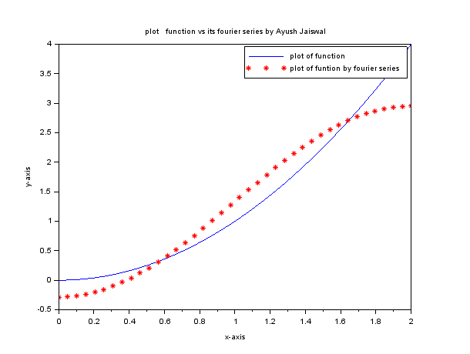

**6.1.2**

**Source Code**

clc

clear

clf

L=input("Enput the value of L=")

n=input("Enter the valu of n=")

*//to find fourircoff bn*

fori=1:n

b(i)=(2/L)*integrate('x^2*sin(i*%pi*x/L)','x',0,L)

end

disp("b",b)

*//comparing the graph of funtion and its sine series*

x=linspace(0,L,40)

y=x^2

series=0

fori=1:n

series=series+b(i)*sin(i*%pi*x/L)

end

plot(x,y)

plot(x,series,"*r")

xtitle("plot function vs its fourier series by Satyam Shrivastav]","x-axis","y-axis")

legend("plot of function","plot of funtion by fourier series")

**Output**

Enput the value of L=2

Enter the valu of n=1

"b"

1.5144300

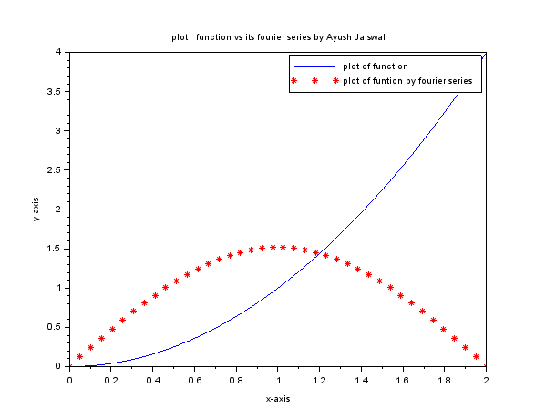

**6.2.1**

**Source Code**

clc

clear

clf

L=input("Enput the value of L=")

n=input("Enter the valu of n=")

*//to find fourircoff a0 n an*

a0=(2/L)*integrate('x','x',0,L)

disp("a0",a0)

fori=1:n

a(1)=(2/L)*integrate('x*cos((i*%pi*x)/L)','x',0,L)

end

disp("a",a)

*//comparing the graph of funtion and its cosine series*

x=linspace(0,L,40)

y=x

series=a0/2

fori=1:n

series=series+a(i)*cos(i*%pi*x/L)

end

plot(x,y)

plot(x,series,"*r")

xtitle("plot function vs its fourier series by Satyam Shrivastav","x-axis","y-axis")

legend("plot of function","plot of funtion by fourier series")

**Output**

Enput the value of L=%pi

Enter the valu of n=1

"a0"

3.1415927

"a"

-1.2732395

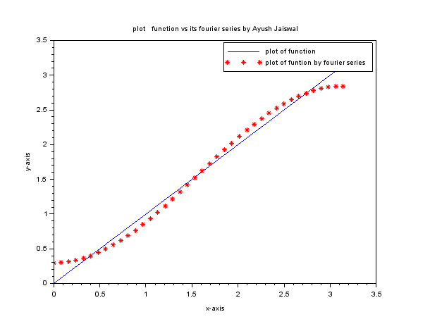

**6.2.2**

**Source Code**

clc

clear

clf

L=input("Enput the value of L=")

n=input("Enter the valu of n=")

*//to find fourircoff bn*

fori=1:n

b(i)=(2/L)*integrate('x*sin(i*%pi*x/L)','x',0,L)

end

disp("b",b)

*//comparing the graph of funtion and its sine series*

x=linspace(0,L,40)

y=x

series=0

fori=1:n

series=series+b(i)*sin(i*%pi*x/L)

end

plot(x,y)

plot(x,series,"*r")

xtitle("plot function vs its fourier series by Satyam Shrivastav","x-axis","y-axis")

legend("plot of function","plot of funtion by fourier series")

**Output**

Enput the value of L=%pi

Enter the valu of n=1

"b"

2.0000000

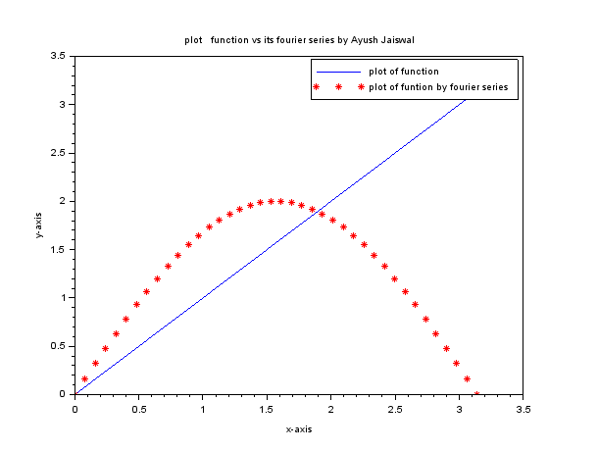

**6.3.1**

**Source Code**

clc

clear

clf

L=input("Enput the value of L=")

n=input("Enter the valu of n=")

*//To find the Fourier coefficients of the Fourier series of y=f(x)= x2*

a0=(2/L)*integrate('x^2','x',0,1)

fori=1:n

a(i)=(2/L)*integrate('(x^2)*cos(i*%pi*x/L)','x',0,1)

b(i)=(2/L)*integrate('(x^2)*sin(i*%pi*x/L)','x',0,1)

end

disp("a0",a0)

disp("a",a)

disp("b",b)

*//comparing the graph of the function and the series.*

x=linspace(0,2,40)

y=x^2

series=a0/2

fori=1:n

series=series+(a(i)*cos(i*%pi*x/L))

series=series+(b(i)*sin(i*%pi*x/L))

end

plot(x,y,)

plot(x,series,"*r")

xtitle("plot function vs its fourier series by Satyam Shrivastav","x-axis","y-axis")

legend("plot of function","plot of funtion by fourier series")

**Output**

Enput the value of L=2*%pi

Enter the valu of n=1

"a0"

0.1061033

"a"

0.0982632

"b"

0.0386938

